2D Player Movement

This is a demonstration for people new to this computer technical skill in video gaming. 2D Player Movement in Unity software.

Step 1. Go to the left column, click on right side of mouse, to open a white box. Click on top of list “Create empty " (Circled in red in the image) Then select from the Heirachy list to create Your character.

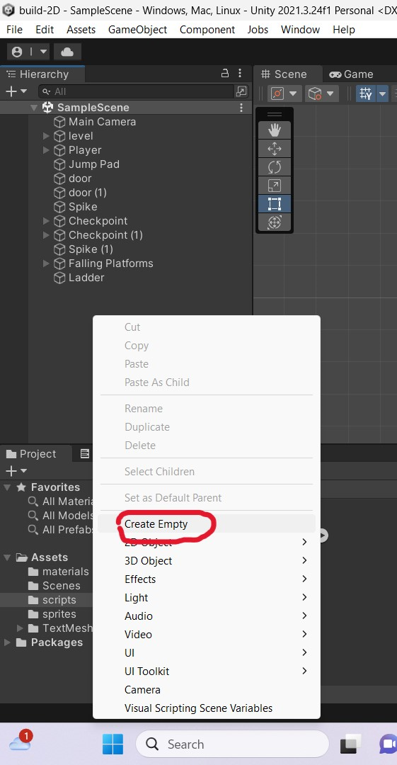

Step 2

Go to right column 'Inspector click at the bottom. "add component". Then click on "Sprite Renderer' then again, add component'.

Step3

Find 'Rigid body 20' then click Gravity scale' to

Collision detection to 'continuous?

4. Sleeping mode, Never sleep, 'interpolate', Interpolate to be ‘Interpolate’.

Click Constraints: tick Freeze Rotation Z.

Step 4

Then add component. Click on Box Collider 2D'

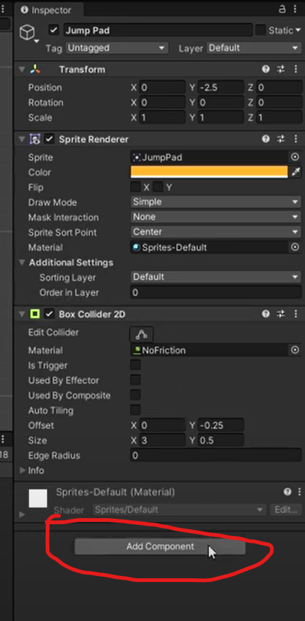

[Step5]

Go to the left column 'sample scene', right click "Player".

Click 'Create empty' in the drop box, to create the

grand of the Click on the it game scenario.

blue-bordered (red) square. Drag

to the small circle which is the 'movement

element' of the character.

Step 6

Click again (sample scene) Player. Then to the right column "inspector" add component, click on movement (script). click on the for right "movement"

[Step 7]

And create coding

{

private float horizontal;

private float speed = 8f;

private float jumpingpower = 16f;

private bool isFaceingRight = true;

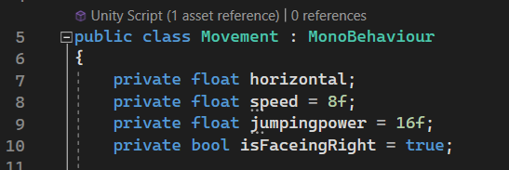

Step 8

Then, click on as indicated below

[SerializeField] private Rigidbody2D rb;

[SerializeField] private Transform groundCheck;

[SerializeField] private LayerMask groundLayer;

Step 9

See the image below; delete these shaded areas.

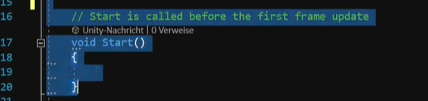

Step 10 Then at void update,

click on horizontal.

{

horizontal = Input.GetAxisRaw("Horizontal");

Flip();

}

Step 11

Click on private void see the coding inside the red circle..

Step12

Add coding for speed jump?

if (Input.GetButtonDown("Jump") && ISGrounded())

{

rb.velocity = new Vector2(rb.velocity.x, jumpingpower);

}

if (Input.GetButtonUp("Jump") && rb.velocity.y > 0f)

{

rb.velocity = new Vector2(rb.velocity.x, rb.velocity.y \* 0.5f);

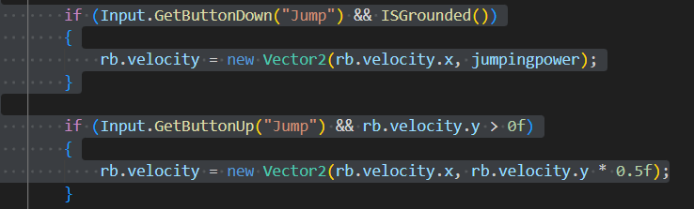

Step 13

Return to UNITY player movement, to insert

Scripts into Assets.

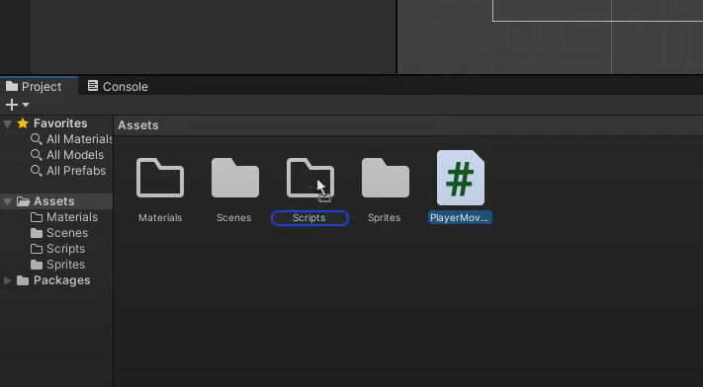

Step 14

When You Have completed the 2D 'grand', click platform (le/t column). Go to right colurun. to Layers, to create the ground feature. You can Select any feature to create a grand surface. Click 6. Ground layer.

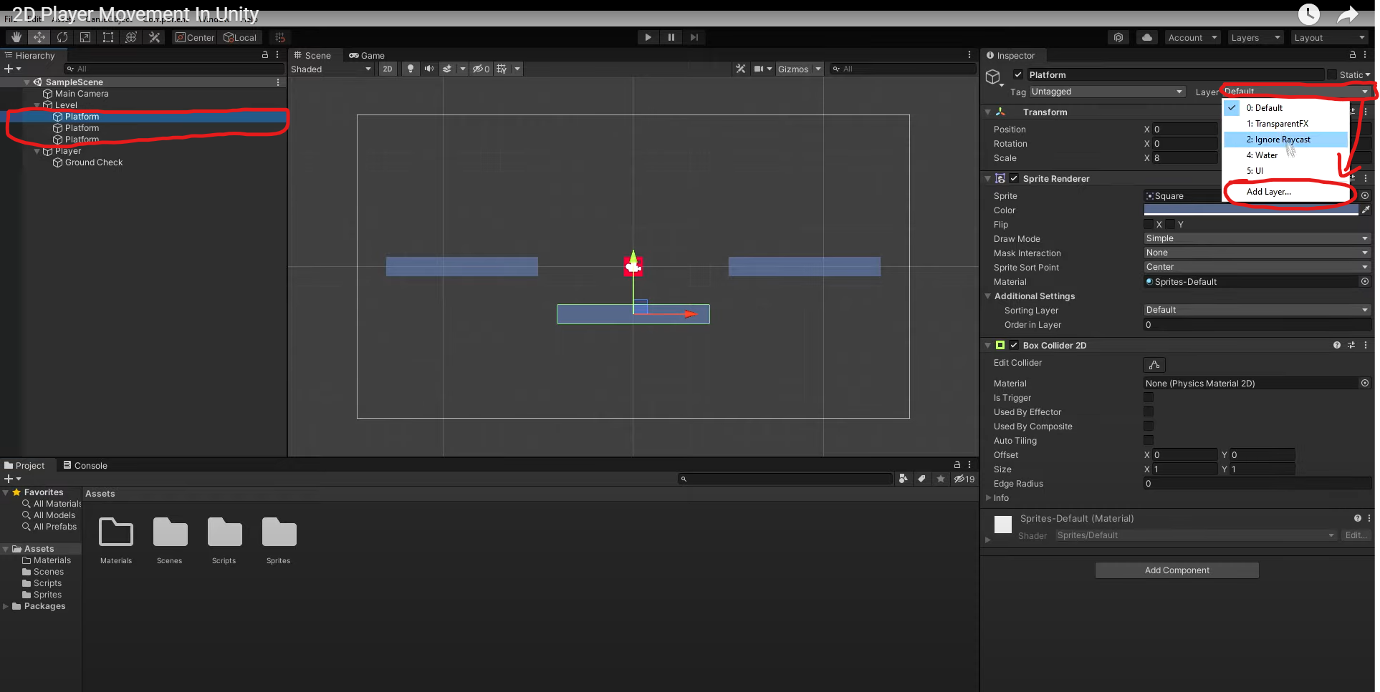

Step 15

See red-circled area below. Open Materials, click it.

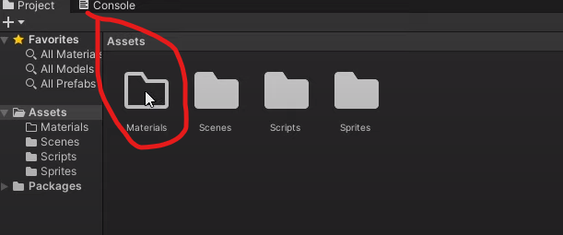

Step 16

Right click: 'create' ,'2D', `Physics Materials', see below.

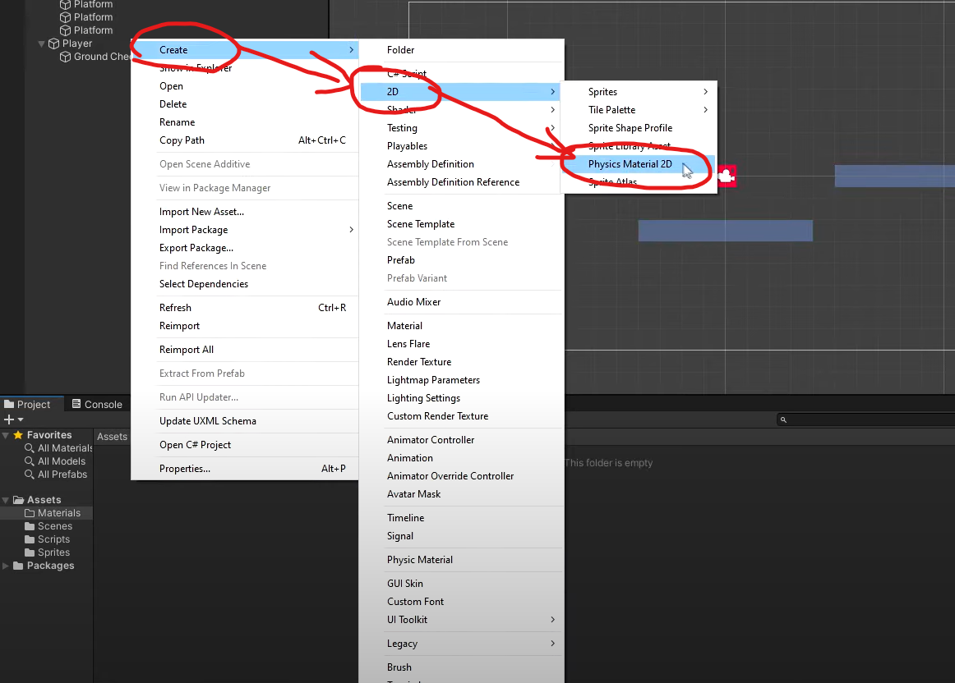

Step 17

See image below, create a title "No friction". Then click number - zero - in friction.

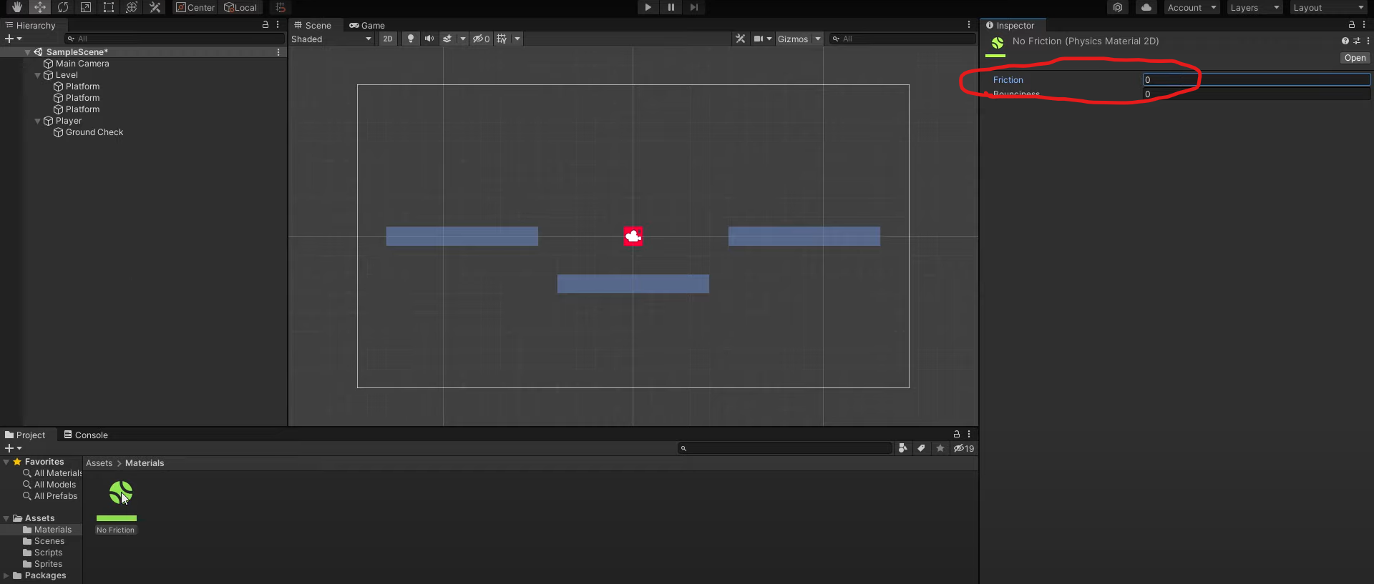

Step 18

At the left column, click Player, then go to the right column drag. Rigidbody 2D into the Movement component. Return to left column, drag (Player) Grand Check to the script (movement component).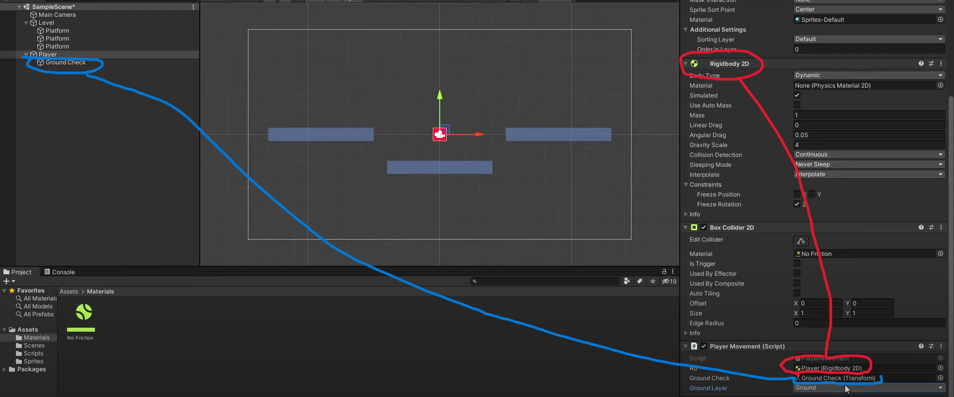

Step 19

final step. Start at beginning to see how the game. operates.